Criterion B: Design

Flowchart - Main Algorithm

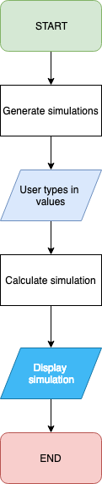

Flowchart - Focused
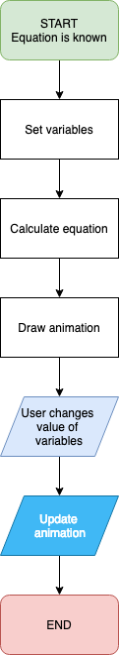

User Interface - Website Layout

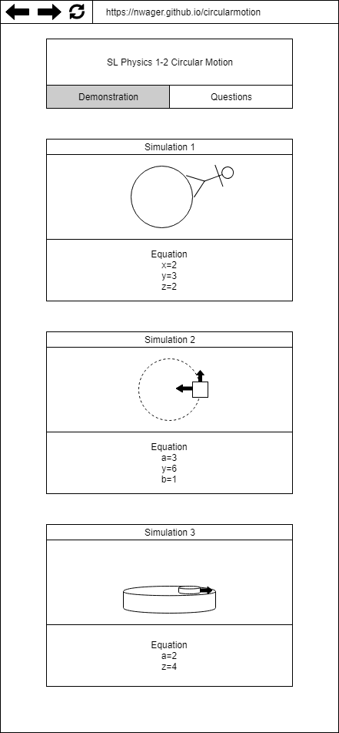

Input
The user will type numbers into input fields. The text will be parsed as an integer.

Output
Simulations will be drawn and animated using canvasses in JavaScript and the values of the input fields. The shapes drawn on the canvas will be created using objects with properties and functions.

Storage
Numbers will only be stored as floats in temporary variables. Nothing is stored outside of the browser session.

Test Plan

Test | Action | Result
Functionality on different browsers | Perform the tests listed below on Chrome, Firefox, and Safari | Program passes tests on each browser
Usability | Let client and other students use the program | Users are able to navigate and understand content of website
Simulation updates based on values | Type three significantly different numbers into each input field | Simulation correctly scales motion and size
Output values are calculated correctly using input values | Type three significantly different numbers into each input field | Output variables are correct for each input value
Simulations can be paused | Click on each simulation, then click again | The simulations stop on the first click, then resume from the same point on the second click

Word count: 186

